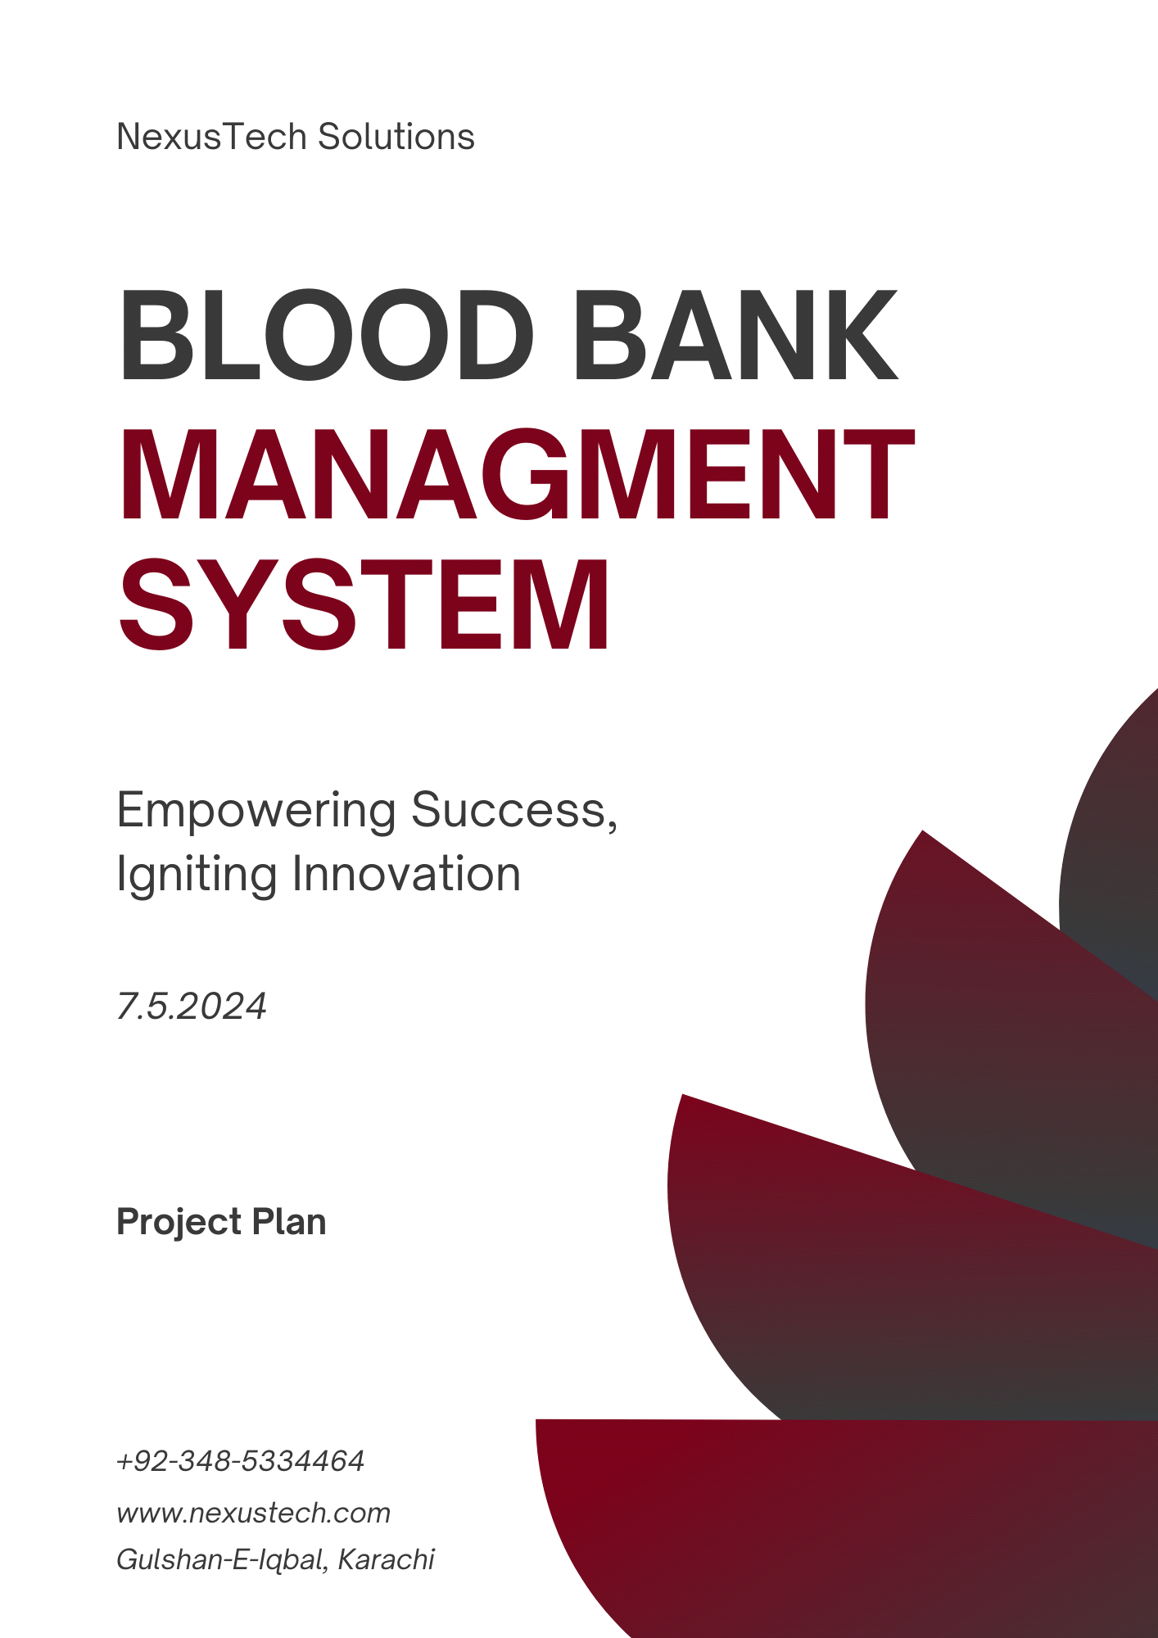



**FAST National University of Computer & Emerging Sciences, Karachi.**

**Submitted to: Mr. Ubaid Aftab**

**Group Members:**

**K213192 Muhammad**

**K213340 Atif Ali**

**K213344 Hamza**

**K214506 Makisa Imtiaz**

**K214512 Alishba Jaffery**

**K214896 Abdullah Islam**

**Business statement**

Blood banks play a crucial role in delivering life-saving transfusions, yet without efficient management systems, challenges arise in monitoring inventory, tracking donations, and ensuring timely distribution. These issues can lead to shortages and delays, endangering patient health. Implementing effective blood bank management systems is vital to address these challenges, ensuring the availability and efficient distribution of blood products and safeguarding lives. Our Blood Bank Management System Software optimizes operations for administrators, donors, and patients, streamlining blood resource management and facilitating life-saving transfusions.

Administrators efficiently oversee all blood bank operations through our software. They access a dashboard displaying blood stock levels, donor statistics, and request statuses. Administrators manage donor and patient records, approve or reject donations and requests, and maintain accurate inventory records.

Donors can easily create accounts and request blood donations through our intuitive platform. They track their donation history and request specific blood units, all accessible on a user-friendly dashboard.

Patients swiftly create accounts and track request statuses, enabling them to request specific blood units and monitor request history for timely transfusions.

We are dedicated to providing a robust, user-friendly blood bank management solution that enhances efficiency, improves patient care, and saves lives.

**Project Team**

**Resources Required**

**Project Manager:** 1 resource

The project manager is responsible for overall project planning, coordination, and execution. They ensure that the project goals are met, stakeholders are managed effectively, and the project stays within scope, budget, and timelines.

**Team Lead:** 1 resource

The team lead oversees the development team, providing technical guidance, resolving issues, and ensuring the successful delivery of project tasks. They facilitate communication between team members and the project manager.

**DevOps Engineer:** 1 resource

The DevOps engineer is responsible for the continuous integration, deployment, and management of the software system. They automate processes, ensure efficient system operations, and collaborate with the development team for smooth delivery.

**Information Security Analyst:** 1 resource

The information security analyst ensures the security of the blood bank management system, identifying potential vulnerabilities, implementing security measures, and conducting security assessments to protect the system from threats.

**Database Analyst:** 1 resource

The database analyst designs and manages the database architecture, including schema design, data storage, retrieval mechanisms, and performance optimization. They ensure data integrity and efficient data handling within the system.

**Risk Analyst:** 1 resource

The risk analyst identifies potential risks and vulnerabilities in the project and develops strategies to mitigate and manage them effectively. They assess the impact and likelihood of risks, implement risk management plans, and monitor risk throughout the project.

**Software Engineers:** 3 resources

Software engineers are responsible for developing the core functionality of the blood bank management system. They implement algorithms, develop modules, and ensure the system meets the specified requirements and quality standards.

**Front-end Developer:** 1 resource

The front-end developer designs and develops the user interfaces and system dashboard. They ensure the user interface is intuitive, visually appealing, and aligns with user experience requirements.

**Back-end Developer:** 1 resource

The back-end developer focuses on developing the back-end system components, including data processing, storage, and integration with external systems. They handle the core logic and functionality of the blood bank management system.

**Business Analyst:** 1 resource

The business analyst gathers and analyzes user requirements, translates them into functional specifications, and collaborates with stakeholders to ensure the system meets business needs. They bridge the gap between business goals and technical implementation.

**Testers:** 4 resources

Testers are responsible for conducting various types of testing, including functional, usability, performance, and security testing. They identify and report defects, validate system functionality, and ensure the quality and reliability of the blood bank management system.

**UI/UX Designer:** 1 resource

The UI/UX designer focuses on creating a user-friendly and visually appealing interface for the blood bank system. They ensure that the system is intuitive, easy to navigate, and provides a positive user experience.

**Software Analyst:** 1 resource

The software analyst assists in requirement gathering, analysis, and documentation. They collaborate with stakeholders to define system specifications, use cases, and user stories. They also provide support to the development team during the implementation phase.

**Customer Support:** 1 resource

The customer support representative provides assistance to end users and stakeholders regarding system usage, troubleshooting, and issue resolution. They handle support requests, communicate with users, and ensure customer satisfaction.

**Technical Writer:** 1 resource

The technical writer is responsible for creating project documentation, including system design documents, user manuals, and technical guides. They ensure that all project information is properly documented and accessible to relevant stakeholders.

**Project Team Structure**

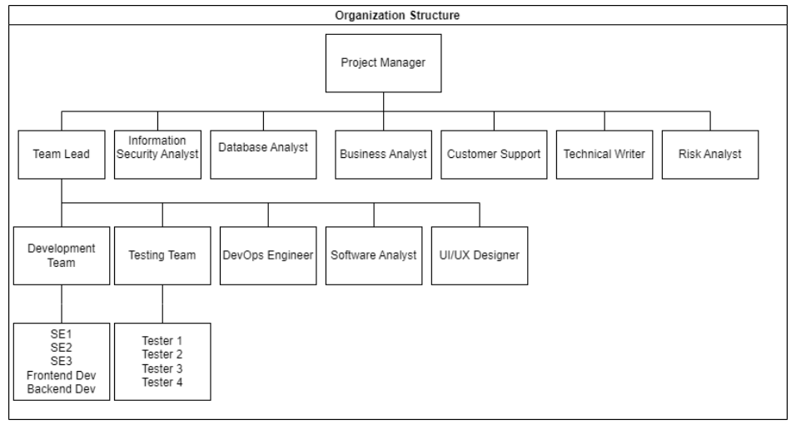

A Controlled Decentralized (CD) team structure would be the best fit. In this setup, decision-making power and responsibilities are shared among team members, with the project manager still overseeing everything. It gives the team more freedom to act independently while keeping everyone on track with the project's goals.

**Feasibility Analysis**

**Technical Feasibility:**

**Rating: 9**

It assesses whether the proposed system can be developed using the available technology and infrastructure.The technical feasibility for the blood bank management system is high as the necessary technology and infrastructure are readily available. With modern database management systems, development frameworks, and integration tools, creating the system is achievable. However, complexities may arise from integrating with existing healthcare systems.

**Economic Feasibility:**

**Rating: 8**

It evaluates whether the proposed system is financially viable and whether the expected benefits of the system outweigh the costs. Economic feasibility is high as the blood bank management system can lead to cost savings and efficiency gains by optimizing inventory management and resource allocation. The expected benefits, such as improved patient care and reduced wastage, outweigh the costs. However, careful evaluation of initial investment and ongoing maintenance expenses is necessary.

**Operational Feasibility:**

**Rating: 9**

It assesses whether the proposed system can be effectively integrated into the existing operations and processes of the organization.Operational feasibility is high as there is a clear need for efficient blood bank management systems to streamline operations and enhance patient care. Challenges may arise in user adoption and training, but proper training programs and change management strategies can mitigate these challenges. Integrating with existing healthcare processes may require careful planning.

**Legal Feasibility:**

**Rating: 8**

It evaluates whether the proposed system complies with legal and regulatory requirements. Legal feasibility is moderate to high, as compliance with regulatory requirements is crucial. Ensuring patient data privacy and compliance with healthcare regulations is essential. While the system is designed to enhance patient care, navigating legal frameworks and obtaining necessary approvals may pose challenges.

**Critical Success Factors:**

**1. Accuracy of Inventory Management:**

* Accurate tracking of blood inventory is critical to ensure timely access to required blood units and prevent shortages or wastage.
* Measures: Implementing robust inventory tracking systems and regular auditing processes to maintain accuracy.

**2. Reliability of Donor and Patient Data:**

* Ensuring the reliability of donor and patient data is essential for maintaining patient safety and effective blood donation processes.
* Measures: Implementing secure data storage and access controls, along with regular data validation and verification processes.

**3. Timely Response to Blood Requests:**

* Timely response to blood requests is critical for patient care and emergency situations.
* Measures: Implementing efficient notification systems and streamlined request processing workflows to ensure prompt response times.

**4. User-Friendly Interface:**

* A user-friendly interface is crucial for efficient system usage by administrators, donors, and patients.
* Measures: Conducting user testing and gathering continuous feedback to improve interface usability and accessibility.

**Project Aims and Goals  
  
Aim of the Project:**

The aim of the project is to develop an advanced management system for blood banks that can efficiently detect and address operational challenges, such as inventory shortages, donation irregularities, and emergency response. The system aims to enhance the overall efficiency, safety, and effectiveness of blood bank operations, ultimately saving more lives and improving patient care.

**Goals of the Project:**

1. Robust Inventory Management:

Develop a comprehensive inventory management system capable of accurately tracking blood supplies, expiration dates, and storage conditions. The system should provide real-time visibility into inventory levels and facilitate efficient allocation and distribution of blood products.

2. Donor Management Enhancement:

Implement features to streamline donor registration, screening, and donation processes. The system should enable easy management of donor information, donation history, and eligibility criteria, ensuring a steady and reliable donor pool.

3. Automated Blood Screening and Testing:

Integrate automated blood screening and testing capabilities to ensure the safety and quality of donated blood. The system should support rigorous testing protocols, compliance with regulatory standards, and timely processing of blood samples.

4. Emergency Response and Alerting:

Develop an alerting mechanism to notify administrators of critical events, such as inventory shortages, abnormal donation patterns, or emergency blood requests. The system should enable prompt action to mitigate risks and address urgent needs.

5. Efficient Transfusion Management:

Enhance transfusion management capabilities to facilitate seamless matching of blood products with patient needs. The system should support real-time tracking of blood transfusions, patient records integration, and adherence to transfusion protocols.

**Benefits to the Organization:**

1. Enhanced Operational Efficiency

Implementing an advanced blood bank management system will streamline operations, reduce manual errors, and optimize resource utilization, leading to significant cost savings and improved productivity.

2. Improved Patient Care

By ensuring the availability of safe and quality blood products, the organization can enhance patient care outcomes, minimize transfusion-related complications, and contribute to better healthcare delivery.

3. Regulatory Compliance and Risk Mitigation

The system's adherence to regulatory standards and best practices will mitigate compliance risks, safeguard patient safety, and enhance the organization's reputation as a trusted healthcare provider.

4. Data-driven Decision Making

Access to real-time data and analytics will empower administrators to make informed decisions, identify trends, and implement proactive measures to address emerging challenges and opportunities.

5. Stakeholder Satisfaction and Loyalty

Providing a reliable and efficient blood bank management system will foster trust and loyalty among donors, healthcare professionals, and regulatory authorities, enhancing the organization's reputation and market competitiveness.

6. Research and Development Opportunities

This project presents valuable chances for advancing blood management and safety, fostering innovation, and positioning our organization as a leader in the field.

7.Collaboration and Partnerships

Successfully implementing the blood bank management system can lead to partnerships with technology firms, healthcare providers, and regulatory bodies, creating growth opportunities and facilitating knowledge exchange.

8. Professional Growth and Expertise

Our team gains invaluable experience in developing advanced blood bank management systems, honing skills in inventory management, donor tracking, and transfusion processes, thereby enhancing our proficiency in healthcare solutions.

9. Social Impact

Efficient blood resource management and timely transfusions contribute positively to society, showcasing our commitment to improving healthcare outcomes and supporting community welfare.

**Project Deliverables**

**1.** **Blood Bank Management System Software:**

Development and deployment of software designed to efficiently oversee blood bank tasks, including tracking inventory, managing donors, and handling transfusions.

**Success Criteria**: The software is successfully installed and set up on designated hardware, seamlessly blending with existing blood bank systems and effectively managing all required tasks.

**2.** **Donor Management Enhancement:**

Introduction of features to simplify donor registration, screening, and donation processes, ensuring a dependable donor pool and smooth blood collection.

**Success Criteria:** The donor management system smoothly integrates into the software, making donor registration, screening, and donation tracking straightforward and accurate.

**3. Automated Blood Screening and Testing:**

Incorporation of automated blood screening and testing systems to guarantee the safety and quality of donated blood products.

**Success Criteria:** The automated screening and testing systems integrate seamlessly, providing precise and timely results while meeting regulatory standards and quality assurance requirements.

**4. Emergency Alerting Mechanism:**

Implementation of an alert system to inform administrators promptly about crucial events, such as low inventory or urgent blood requests.

**Success Criteria:** The alert system is integrated into the software, swiftly notifying administrators of important events with real-time alerts, ensuring prompt action in emergencies.

**5. User Training and Documentation:**

Provision of clear documentation and user manuals to aid in system adoption and ongoing support.

**Success Criteria:** The documentation and user manuals offer straightforward instructions for system setup, configuration, and maintenance, ensuring ease of use. Additionally, user training sessions equip staff with the skills needed to effectively operate the software.

6. **Technical Support:**

Provision of timely technical assistance during deployment and a specified warranty period to ensure smooth system operation and address any concerns.

**Success Criteria:** Technical support is available to address queries, assist with setup or configuration, and promptly resolve reported issues, ensuring uninterrupted use of the blood bank management system.

**Project Scope**

**Project Boundaries:**

The project scope is to develop and deploy a blood bank management system, focusing on optimizing blood resource management, donor coordination, and transfusion processes within defined limitations.

**Included:**

* **System design and development:** Designing and developing the blood donation system including user interfaces, database architecture, and backend functionality.
* **Procurement:** Identifying, evaluating, and acquiring blood testing and screening devices suitable for integration with the blood donation system.
* **Integration with Software**: Implementing seamless integration between the acquired blood testing and screening device and the existing software infrastructure, enabling efficient data exchange and automation of testing processes.
* **Testing and quality assurance:** Ensuring the system functions correctly through rigorous testing procedures to identify and fix any issues or bugs.
* **Deployment and implementation:** Deploying the system onto servers or cloud platforms and implementing it for use by administrators, donors, and patients.
* **User training and support:** Providing training materials and support to users (administrators, donors, and patients) to ensure they understand how to use the system effectively.
* **Documentation and knowledge transfer:** Creating comprehensive documentation that outlines system functionality, usage instructions, and best practices for administrators, donors, and patients to facilitate knowledge transfer and future maintenance.

**Excluded:**

* **Procurement of physical infrastructure:** Acquiring necessary hardware components such as servers, networking equipment, and storage devices for system deployment.
* **Installation of hardware components:** Setting up and configuring the hardware infrastructure required to host the blood donation system.
* **Maintenance of procured devices:** Providing support andmaintenance of the integrated blood testing and screening device.
* **Training of external stakeholders:** Providing training sessions for external stakeholders such as volunteers or community members who may interact with the system indirectly.

**Phases of the Project:**

* **Initiation and Planning:** Define project scope and requirements for the blood bank management system, including both Admin, Donor, and Patient modules. Also plan for procuring a blood testing and screening device.
* **Procurement of Blood Testing and Screening Device:** Identify suitable blood testing and screening devices, evaluate options, and procure the selected device.
* **Design and Development:** Design user interfaces and develop backend functionalities for Admin, Donor, and Patient modules, ensuring seamless communication and data flow along with the integration of the blood testing and screening device into the system architecture.
* **Testing and Quality Assurance:** Conduct extensive testing across blood testing and screening device, Admin, Donor, and Patient modules to ensure functionality, security, and user experience meet the project requirements.
* **Deployment and Implementation:** Deploy the complete blood bank management system, including Admin, Donor, and Patient modules, ensuring proper integration and functionality.
* **Training and User Adoption:** Provide training sessions on the usage of integrated blood testing and screening device also for Admins, Donors, and Patients on how to effectively use the system for blood donation, requests, and management.
* **Maintenance and Support:** Offer ongoing maintenance and technical support for the entire system, addressing any issues and implementing updates to enhance performance and security.
* **Project Closure and Evaluation:** Conduct a comprehensive evaluation of the entire system's performance, gather feedback from Admin, Donor, and Patient, and finalize project documentation, concluding the project phase.

**Success Criteria:**

- Successful deployment of the blood bank management system within the defined scope, timeline, and budget.

- Achievement of project goals and objectives, including improved operational efficiency and patient care outcomes.

- Positive feedback from stakeholders and end users regarding system usability, reliability, and effectiveness.

- Compliance with regulatory standards and best practices in blood banking and healthcare management.

**Software Process Model:**

For the blood bank management system software, a suitable software process model would be the **Iterative and Incremental Development** model due to its alignment with the project's requirements:

* **Iterative Development:** The project progresses through iterations, refining specific modules like Admin, Donor, and Patient functionalities with each cycle.
* **Incremental Development:** New features are added gradually, starting with essentials like user authentication and blood stock management and expanding to more complex functions over subsequent iterations.
* **Feedback and Adaptation:** Continuous feedback loops involve stakeholders such as administrators, donors, and patients, ensuring the system aligns with their needs. This feedback guides iterative improvements, ensuring alignment with user needs and industry standards.
* **Risk Management:** By breaking the project into manageable iterations, the IID model facilitates effective risk management for the blood bank management system. Potential risks, such as security vulnerabilities or usability issues, are identified and addressed early in the development process, minimizing the likelihood of major setbacks or disruptions to blood bank operations. This proactive approach to risk management enhances the overall reliability and stability of the system.
* **Continuous Improvement:** Each iteration incorporates feedback, helping the system improve and adjust to changing needs and new technology, ensuring it stays effective in managing blood donation and distribution.

**User Stories**

**Product Owner:**

* As a product owner, I want to specify the desired inventory accuracy and tracking precision in the blood bank management system to ensure efficient inventory management and patient care.
* As a product owner, I want to ensure that the blood bank management system meets our requirements for accuracy, efficiency, and security, providing reliable data for blood inventory management and patient care.

**System User:**

* As a **patient**, I want to easily register and request blood, view real-time inventory status, and receive notifications for blood availability, ensuring timely access to required blood units.
* As an **administrator**, I want to input relevant data such as donor information and blood types, view real-time inventory status, and receive alerts for critical inventory levels, facilitating efficient blood bank management.
* As a **donor**, I want to easily register, donate blood, and track my donation history, ensuring a seamless donation process and contributing to blood bank operations.

**Developer:**

* As a developer, I want to optimize the blood bank management system for scalability and performance, ensuring it can handle fluctuations in blood supply and demand effectively.
* As a developer, I want to implement secure data storage and access controls in the blood bank management system to protect sensitive donor and patient information.

**Project Manager:**

* As a project manager, I want to track development progress and receive feedback from stakeholders, ensuring continuous improvement of the blood bank management system to meet evolving needs.
* As a project manager, I want to ensure adherence to project milestones and timelines, facilitating the timely delivery of the blood bank management system for operational use.

**Assumptions, Constraints, and Dependencies**

1. **Time Constraints:**

The project is set to commence on March 4th, 2024, with a targeted completion within 10 months. Adhering strictly to the timeline is imperative to ensure timely development, deployment, and testing of the blood bank management system.

2. **Resource Constraints:**

Adequate resources must be allocated for successful project implementation. This includes skilled software developers, data scientists for system optimization, system administrators, and technical support staff. Additionally, ample hardware resources, such as computers and storage devices, must be provided to support the system's operations.

3. **Financial Constraints:**

The project budget needs to cover all essential expenses, including software development, hardware acquisition, system integration, documentation, training, and ongoing technical support. Proper financial planning and resource allocation are vital to ensure the project's financial viability.

4. **Business Constraints:**

Success relies on the cooperation and support of relevant stakeholders in the blood bank ecosystem. Coordination with authorities, blood bank staff, and healthcare professionals is necessary to integrate the system seamlessly with existing processes and infrastructure.

5. **Technical Constraints:**

The system should efficiently manage a large database of donor and patient information while ensuring data accuracy and security. It should also be scalable to accommodate potential increases in demand for blood products and services. Additionally, the system should adhere to regulatory standards and privacy requirements.

6. **External Factors:**

External factors like power supply stability, network connectivity, and internet bandwidth availability could impact system performance. Contingency plans should be in place to mitigate risks arising from such factors. Compliance with legal and regulatory requirements, including data privacy and security standards, is essential for project success.

**Stakeholders**

**Identification and Responsibilities of Stakeholders**

1. **Admin**

- Oversees project coordination and management.

- Defines project objectives, goals, and success criteria.

- Facilitates communication among stakeholders.

- Obtains necessary approvals and sign-offs.

**Signing Authority:** Project Manager, Product Owner

2. **Blood Donors and Patients**

- End-users of the system.

- Provide input on system requirements and usability.

- Use the system to request and access blood supplies.

- Offer feedback for system improvement.

**Signing Authority:** Project Manager, Product Owner

3. **Software Developers**

- Responsible for software development and implementation.

- Develop modules for inventory management, donor/patient records, and blood request tracking.

- Implement security measures and optimize system performance.

**Signing Authority:** Project Manager, Product Owner, Lead Developer

4. **Project Manager**

- Plans, coordinates, and executes the project.

- Defines project objectives, goals, and success criteria.

- Manages timelines, milestones, and resources.

- Facilitates communication among stakeholders.

**Signing Authority:** Project Manager, Stakeholders

5. **Product Owner**

- Represents stakeholder interests and provides requirements.

- Collaborates with developers to define user stories and prioritize features.

- Reviews and approves deliverables.

- Offers feedback and guidance.

**Signing Authority:** Product Owner, Stakeholders

6. **Security Personnel**

- Ensures system security.

- Provides input on security requirements and compliance.

- Collaborates with developers to implement security measures.

**Signing Authority:** Project Manager, Security Personnel

7. **Healthcare Authorities**

- Stakeholders overseeing blood bank operations.

- Provide input on system requirements, especially related to inventory management and patient safety.

- Collaborate to ensure system alignment with healthcare protocols.

**Signing Authority:** Healthcare Authorities, Stakeholders

8. **Regulatory Bodies**

- Ensure compliance with legal and regulatory requirements.

- Provide guidelines for system implementation and data privacy.

- Collaborate with the project team to address regulatory concerns.

**Signing Authority:** Government, Stakeholders

**Expert**

**Name:** Miss Hajra Ahmed

**Job Title:** Lecturer and Researcher

**Experience: 6.5 years**

**Reason for choosing her:** She has good experience in software development and engineering. We chose her as an expert so that we can plan our project properly by taking advantage of her experience in this field.

**Her role in our project:** provided a comprehensive overview, detailed feedback, and guidance throughout the project, ensuring alignment with objectives, milestones, deadlines, and resource management. Her technical expertise and knowledge enhanced the team's skills and decision-making, playing a crucial role in navigating challenges.

**Work Breakdown Structure**

* **1. Initiation Phase**
* 1.1 Define project goals and objectives
* 1.1.1Identify the need establishes primary objectives for a blood bank management system software
* 1.2 Gather requirements for Minimum Viable Product
* 1.2.1 Identify core functionalities essential for initial implementation, focusing on immediate needs of blood bank management system.
* 1.2.1 Define requirements for inventory management, donor/patient records, and blood request processing to ensure basic system functionality.
* 1.3 Conduct a feasibility study
* 1.3.1 Assess the technical feasibility of implementing the blood bank management system software, ensuring compatibility with existing infrastructure and systems.
* 1.3.2 Evaluate financial feasibility by estimating costs and benefits, determining the project budget to ensure financial viability.
* 1.4 Identify project stakeholders
* 1.4.1 Identify and determine the roles, responsibilities, and expectations of the key stakeholders including blood bank staff, healthcare professionals, and regulatory bodies
* 1.5 Define project scope
* 1.5.1 Establish the boundaries and deliverables of the blood bank management system software
* 1.5.2 Identify the limitations and exclusions of the project
* 1.6 Develop project charter
* 1.6.1 Document the project objectives, scope, and stakeholders involved in the development and implementation of the blood bank management system software.
* **2. Requirement Gathering and Analysis Phase**
* 2.1 Conduct administrators, donors, and patients interviews and workshops
* 2.1.1 Engage with administrators, donors, and patients to understand their needs and requirements
* 2.2 Elicit functional requirements
* 2.2.1 Identify the key functionalities and features of the blood bank management system software and document the specific requirements related to inventory management, donor/patient records, and blood request tracking
* 2.3 Elicit non-functional requirements
* 2.3.1 Identify the performance, security, and usability requirements of the system and document requirements related to system scalability, reliability, and availability
* 2.4 Analyze requirements and prioritize
* 2.4.1 Review and analyze gathered requirements for clarity and consistency and prioritize requirements based on their importance and impact such as donor registration, blood inventory tracking
* 2.5 Define system architecture
* 2.5.1 Design the high-level architecture of the blood bank management system software
* 2.6 Develop requirements documentation
* 2.6.1 Create a detailed requirements specification document that includes functional and non-functional requirements, use cases, and user stories
* **3. Design Phase**
* 3.1 Design system components and modules
* 3.1.1 Design the backend system architecture and database schema
* 3.1.2 Define the data models and relationships within the system to accurately represent blood inventory, donor/patient information, and blood request data.
* 3.1.3 Design the user interface and system dashboard layout for administrator, patients and donor modules
* 3.2 Develop wireframes and prototypes
* 3.2.1 Create visual representations of the user interface and system screens incorporating feedback from administrator, patients and donors
* 3.2.2 Develop interactive prototypes to demonstrate system functionality
* 3.3 Define system workflows and processes
* 3.3.1Identify and document the sequence of actions and interactions involved in blood inventory management, donor registration, and blood request processing. Document the workflows and process diagrams for system operation
* 3.4 Conduct technology selection and evaluation
* 3.4.1 Evaluate and select appropriate technologies for implementing the blood bank management system software
* 3.5 Perform risk assessment and mitigation planning
* 3.5.1 Identify potential risks and vulnerabilities in the project associated with the development and implementation of the blood bank management system.
* 3.5.2 Categorize risks into technical, operational, and regulatory categories to facilitate comprehensive risk analysis and assess the potential impact and likelihood of each risk. Develop strategies and actions to mitigate identified risks
* 3.6 Create detailed system design
* 3.6.1 Develop detailed design specifications defining the structure and components of the blood bank management system.
* 3.6.2 Specify and design data models according to the functionality and interactions of system modules, including inventory management, donor/patient records, and blood request processing.
* 3.7 Design database and storage architecture
* 3.7.1 Determine the database management system best suited for storing and managing blood bank data, design the database schema and tables to efficiently store and organize blood inventory, donor information, patient records, and blood request data.
* 3.8 Design system security measures
* 3.8.1 Identify security requirements and threats specific to the blood bank management system, including unauthorized access, data breaches, and malware attacks.
* 3.9 Develop system documentation
* 3.9.1 Document the system design, including architecture and data flow diagrams

covering all aspects of the blood bank management system, including system architecture, design specifications, and user manuals.

* **4. Development and Integration Phase**
* 4.1 Set up the development environment
* 4.1.1Install required development tools and software and configure the development environment for the project
* 4.2 Implement backend system components
* 4.2.1. Develop modules for inventory management, donor/patient records, and blood request tracking
* 4.3 Develop a user interface
* 4.3.1 Design and implement a system dashboard for monitoring blood bank data
* 4.3.2 Create user interfaces for system administration and configuration
* 4.4 Implement system integrations
* 4.4.1 Integrate with external systems for data exchange and communication
* 4.5 Implement alert generation and notification
* 4.5.1 Develop mechanisms to generate real-time alerts for inventory shortages and critical events
* 4.6 Integrate blood testing and screening device
* 4.6.1 Integrate the device with system software and test for functionality and correctness
* 4.7 Create development documentation
* 4.7.1 Document codebase and system architecture outlining admin, patient and donor components
* 4.7.2 Generate technical documentation detailing the implementation details of the blood bank management system for future reference.
* **5. Testing Phase**
* 5.1 Develop a test plan
* 5.1.1 Define test objectives, scope, and test coverage related to successful integration of blood testing and screening device, admin, patient and donor modules
* 5.1.2 Write test scenarios based on typical user interactions, including donor registration, blood request processing, and inventory management
* 5.1.3 Develop test cases to validate system functionalities such as donor/patient record management, blood inventory tracking, and request handling.
* 5.2 Conduct functional testing
* 5.2.1 Execute test cases to verify system functionalities like donor registration, blood request processing, and inventory management.
* 5.3 Perform usability testing
* 5.3.1 Evaluate and gather feedback from users and stakeholders including blood bank staff and administrators, to improve UI design and usability.
* 5.4 Conduct performance testing
* 5.4.1 Measure system response time, throughput, and resource usage and validate system performance under expected load conditions
* 5.5 Perform security testing
* 5.5.1 Verify system security measures against potential threats such as unauthorized access and data breaches.
* 5.6 Conduct system acceptance testing
* 5.6.1 Collaborate with administrator, patient and donor to define acceptance criteria and execute test cases to ensure the system meets user expectations
* 5.7 Address and resolve issues
* 5.7.1 Document and track reported issues and defects
* 5.7.2 Assign resources to investigate and fix reported issues
* 5.8 Retest and validate fixes
* 5.8.1 Retest resolved issues to ensure they have been effectively addressed and validate that fixes do not introduce new issues or regressions
* 5.9 Conduct system performance testing
* 5.9.1 Measure system performance under peak load conditions also analyze performance metrics and identify areas for optimization and optimize system performance and scalability based on test results
* 5.10 Conduct user acceptance testing (UAT)
* 5.10.1 Collaborate with end users to define UAT scenarios and test cases to validate system usability and effectiveness
* 5.11 Generate test reports
* 5.11.1 Document test results, including test execution details and outcomes, summarize key findings, issues, and recommendations also share test reports with stakeholders for review and sign-off
* **6. Deployment Phase**
* 6.1 Prepare deployment environment
* 6.1.1 Set up production servers and infrastructure and configure necessary network and security settings
* 6.2 Migrate system to production environment
* 6.2.1 Deploy the developed system on production servers and transfer relevant data to the production environment
* 6.3 Conduct user training
* 6.3.1 Provide training sessions to educate users on system functionalities
* 6.4 Perform system validation
* 6.4.1 Validate the deployed system against the defined acceptance criteria and conduct final system checks to ensure readiness for operation
* 6.5 Prepare documentation for deployment
* 6.5.1 Create deployment guides and instructions and document system configurations and setup procedures
* **7. Maintenance and Support Phase**
* 7.1 Establish support mechanisms
* 7.1.1Set up a help desk or support team for users to report issues and define support processes and escalation procedures
* 7.2 Monitor system performance and stability
* 7.2.1 Implement system monitoring tools to track performance metrics
* 7.3 Provide ongoing maintenance and bug fixes
* 7.3.1 Release bug fixes and updates to ensure system stability
* 7.4 Prioritize and plan system enhancements based on user needs and business requirements
* 7.4.1 Implement new features and functionalities to improve system capabilities
* 7.4.2 Test and validate system enhancements before deployment
* **8. Project Closure Phase**
* 8.1 Conduct final project review
* 8.1.1 Evaluate project performance against initial objectives and success criteria. Review project deliverables and ensure completeness, quality and identify lessons learned and areas for improvement for future projects
* 8.2 Document project closure report
* 8.2.1 Summarize project achievements, challenges, and lessons learned and capture final project documentation, including updated system documentation
* 8.3. Handover system to the operational team
* 8.3.1 Provide necessary documentation and training materials for ongoing system management
* 8.4 Celebrate project completion
* 8.4.1 Recognize and appreciate the project team's efforts and contributions in a project closure meeting or event to acknowledge project success

**Risk Management**

**1. Data Security Breach**

* Risk: There is a risk of unauthorized access to sensitive donor and patient information, leading to breaches of confidentiality and potential legal consequences.
* Probability: Moderate
* Impact: High
* Mitigation: Implement robust data encryption protocols, access controls, and regular security audits. Conduct employee training on cybersecurity best practices and establish incident response procedures to address breaches promptly.

**2. System Downtime**

* Risk: The blood bank management system may experience unexpected outages or downtime, disrupting blood inventory management and potentially impacting patient care.
* Probability: Moderate
* Impact: High
* Mitigation: Implement redundant hardware and backup systems to minimize the risk of system failures. Conduct regular maintenance and testing to identify and address potential issues proactively. Establish clear communication channels for notifying stakeholders in case of downtime and implementing contingency plans to mitigate impacts.

**3. Inaccurate Inventory Tracking**

* Risk: There is a risk of inaccuracies in blood inventory tracking, leading to shortages or overstocking of blood units and affecting patient care.
* Probability: Moderate
* Impact: High
* Mitigation: Implement automated inventory management systems with barcode scanning and real-time tracking capabilities to minimize manual errors. Conduct regular inventory audits and reconciliation processes to ensure data accuracy. Implement alerts and notifications for low inventory levels to prompt timely replenishment.

**4. Integration Challenges**

* Risk: Integrating the blood bank management system with existing healthcare IT systems may pose technical challenges, leading to data synchronization issues and workflow disruptions.
* Probability: High
* Impact: High
* Mitigation: Conduct thorough compatibility assessments and testing before integration to identify potential issues early. Collaborate closely with IT team to address challenges and establish clear communication channels for troubleshooting and resolving integration issues. Implement phased integration strategies to minimize disruptions to daily operations.

**5. Insufficient User Adoption**

* Risk: There is a risk of resistance or insufficient adoption of the blood bank management system by users, leading to underutilization and inefficiencies in blood bank operations.
* Probability: High
* Impact: High
* Mitigation: Provide comprehensive training programs and ongoing support to users to familiarize them with the system and address any concerns or challenges. Gather feedback from users and incorporate user-centric design principles to enhance usability and address user needs.

|  |  |  |  |  |
| --- | --- | --- | --- | --- |
| Probability | High |  |  | R4, R5 |
| Moderate |  |  | R1, R2, R3 |
| low |  |  |  |
|  | | Low | Moderate | High |
| Impact | | |